Michal Kleofas Oginski

First and foremost, you should realise the truth: a human being is not the result of coincidence; nobody is born without a mission. It is God, the Creator, that we owe our gratitude to for everything.

Precepts for my son

Mikalojus Konstantinas Čiurlionis

I have always wanted you to become a man, who feels and understands everything and seeks Truth, Goodness and Beauty.

From a letter to his brother Povilas

Nicholas Roerich:

He, who goes to the Good, is blessed on all paths.



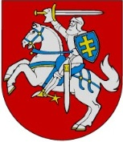
Organisers:

Committee on Education, Science and Culture of the Seimas of the Republic of Lithuania
Ministry of Culture of the Republic of Lithuania

Lithuanian Roerich Society
Lithuanian Committee for the Banner of Peace, a division of the International Committee for the Banner of Peace under the UN

Oginski Cultural History Museum of Rietavas  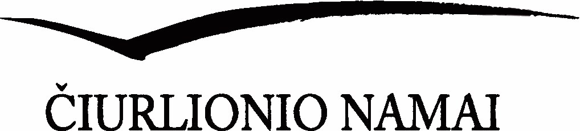 | 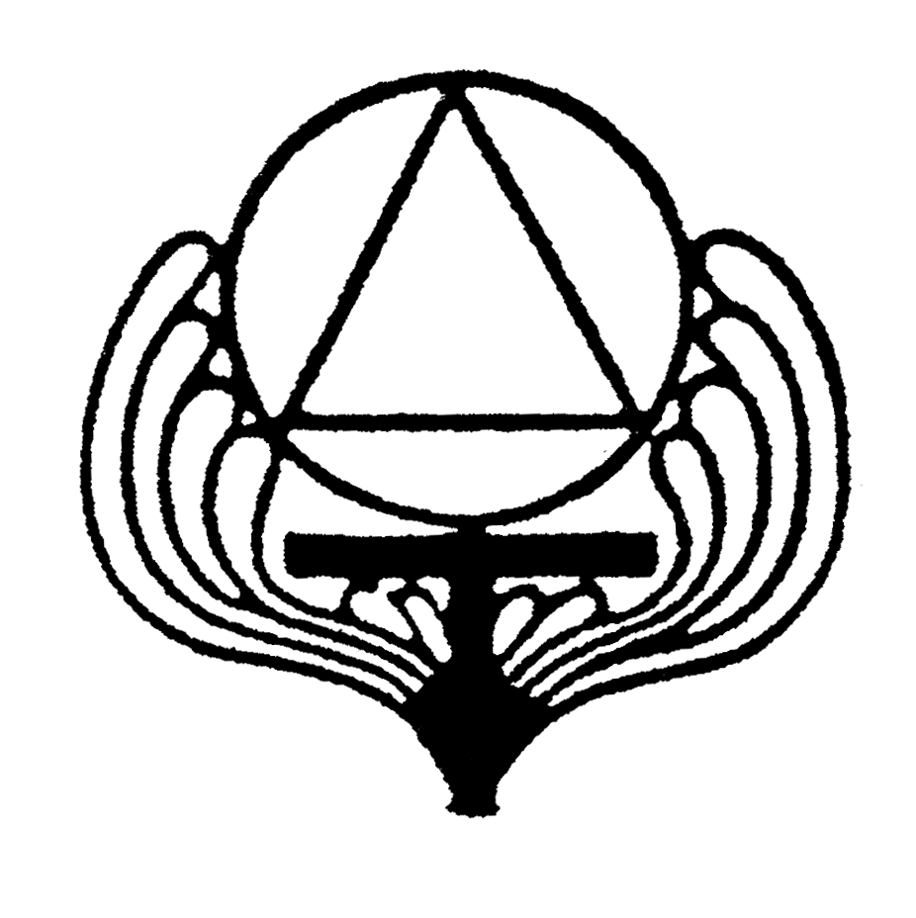  Vydūnas Society


International Association PEACE through CULTURE–Europe
Sponsors:
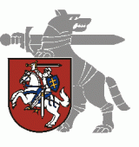
Ministry of National Defence of the Republic of Lithuania


  Union of the Baltic Cities |   Baltic–Turkish Culture Academy

INTERNATIONAL CONFERENCE

The Great Promoters of Culture

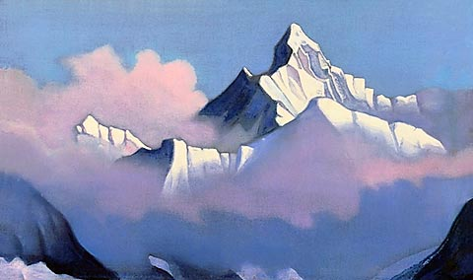
Himalayas. 1937. By Nicholas Roerich

PROGRAMME

15 April 2015
Constitution Hall
Seimas of the Republic of Lithuania

Events to mark the Universal Day of Culture  10⁰⁰ Banner of Peace Hoisting Ceremony in Independence Square  11⁰⁰–15⁰⁰ International Conference  The Great Promoters of Culture  Constitution Hall  Seimas of the Republic of Lithuania  Gedimino pr. 53, Vilnius  18⁰⁰ Holy Mass for people working in the cultural sector  19⁰⁰ Concert Inspired by Čiurlionis  Sts. Johns’ Church  Co-organised by  the Division of Culture of Vilnius City Municipality and the House of Mikalojus Konstantinas Čiurlionis   | Programme of events  10⁰⁰–10³⁰ Banner of Peace Hoisting Ceremony in Independence Square  Address by:  Loreta Graužinienė, Speaker of the Seimas of the Republic of Lithuania  Dr Auksė NARVILIENĖ, Chairperson, Committee for the Banner of Peace, and Coordinator of the International Committee for the Banner of Peace under the UN  Master of Ceremony: Salvina TAUKINAITIENĖ,  Head, Protocol Unit, Ministry of National Defence of the Republic of Lithuania  10³⁰–11⁰⁰ Opening of the exhibition Pradžia (The Beginning) of Radviliškis Region and the exhibition of replicas of Roerich’s paintings  Parliament Gallery and Stained Glass Gallery  Bard music concert  Moderators:  Prof Vytautas JUOZAPAITIS, Member of the Seimas of the Republic of Lithuania  Dr Auksė NARVILIENĖ, Chairperson, Committee of the Banner of Peace  11⁰⁰–11³⁰ Welcome addresses  Audronė Pitrėnienė, Chair, Committee on Education, Science and Culture, Seimas of the Republic of Lithuania  Šarūnas BIRUTIS, Minister of Culture  Algirdas GAIŽUTIS, academician, Rector of the Lithuanian University of Educational Sciences  Prof. Rokas ZUBOVAS, Director, House of Mikalojus Konstantinas Čiurlionis  Speeches:  11³⁰–11⁴⁵ Irena SELIUKAITĖ, Head, Regional Culture Division, Ministry of Culture of the Republic of Lithuania  Culture in Regions | 11⁴⁵–12⁰⁰ Willy AUGUSTAT, President, International  Association PEACE through CULTURE– Europe, Austria  Religion and Ethics – the Highest Cultural Dimension  12⁰⁰–12¹⁵ Prof Jonas GLEMŽA, Member of the Council of the Lithuanian Culture Congress  80th anniversary of the Roerich Pact  12¹⁵–12³⁰ Vytas RUTKAUSKAS, Director, Oginski Cultural History Museum of Rietavas  Michal Kleofas Oginski. Return to the Homeland  12³⁰–13⁰⁰ Coffee break  13⁰⁰–13¹⁵ Remigijus AUŠKELIS, Lithuanian Roerich Society  Anniversaries of the Lithuanian Roerich Society  13¹⁵–13³⁰ Pavel SAPOTKO, Belarusian State University of Culture and Arts, Oginski Charity Foundation  (Molodechno)  Opportunities and prospects for communicating the historical cultural heritage of Belarus and Lithuania through international clusters  13³⁰–13⁴⁵ Jens STACHURA, International Association PEACE through CULTURE– Europe, Int‘l Advisory Board, Germany  Harmonisation of society by ethical principles  13⁴⁵–14⁰⁰ Dr Vacys BAGDONAVIČIUS, Chairman Emeritus, Vydūnas Society  The Great Men of Lithuania Minor: Donelaitis and Vydūnas  14⁰⁰–14¹⁵ Ishak AKAY, President, Baltic–Turkish Culture Academy  Role of NGOs in developing relations between cultures  14¹⁵–14³⁰ Marco VUKOVIC, Vice-President, International Association PEACE through CULTURE – Europe, Austria  Culture – the Victorious  14³⁰–15⁰⁰ Debate. Concluding remarks          

